Locus and Angle Bisector

Definition
# Source: AI Source: Provided by: [Data Path: Persons Table -> ID Column: 1, Name_En Column: Motasem Essam] -> From: [ChatGPT] on [7/25/2026]
The angle-bisector locus is the locus of all points that are equidistant from two intersecting lines.
If two lines $l_{1}$and $l_{2}$intersect at $O$, then the points $P$satisfying
$$\boxed{d\left(P , l_{1}\right)=d\left(P , l_{2}\right)}$$
lie on the angle bisectors of the angles formed by the two lines.
For two intersecting lines, the complete locus consists of two perpendicular angle-bisector lines.
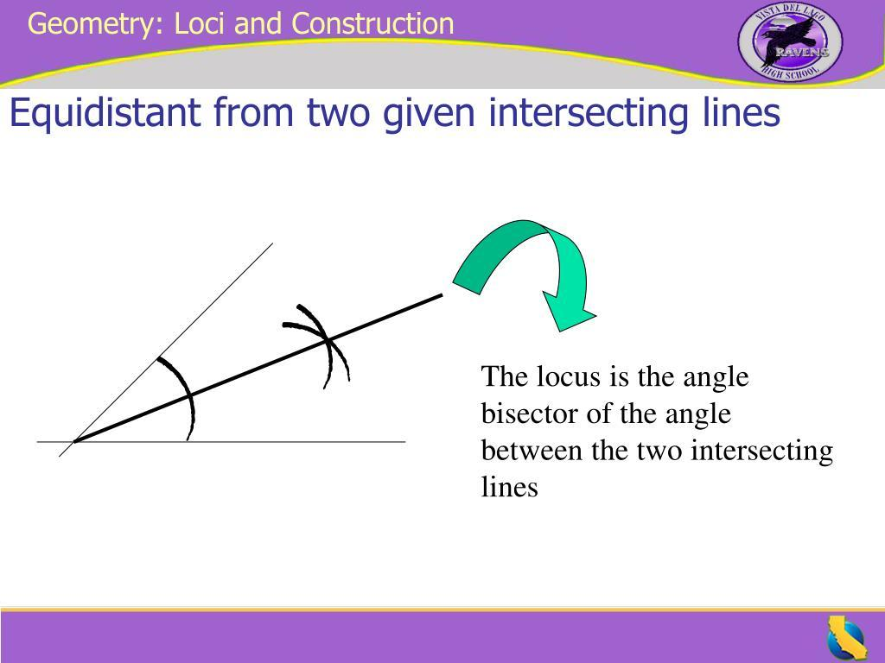
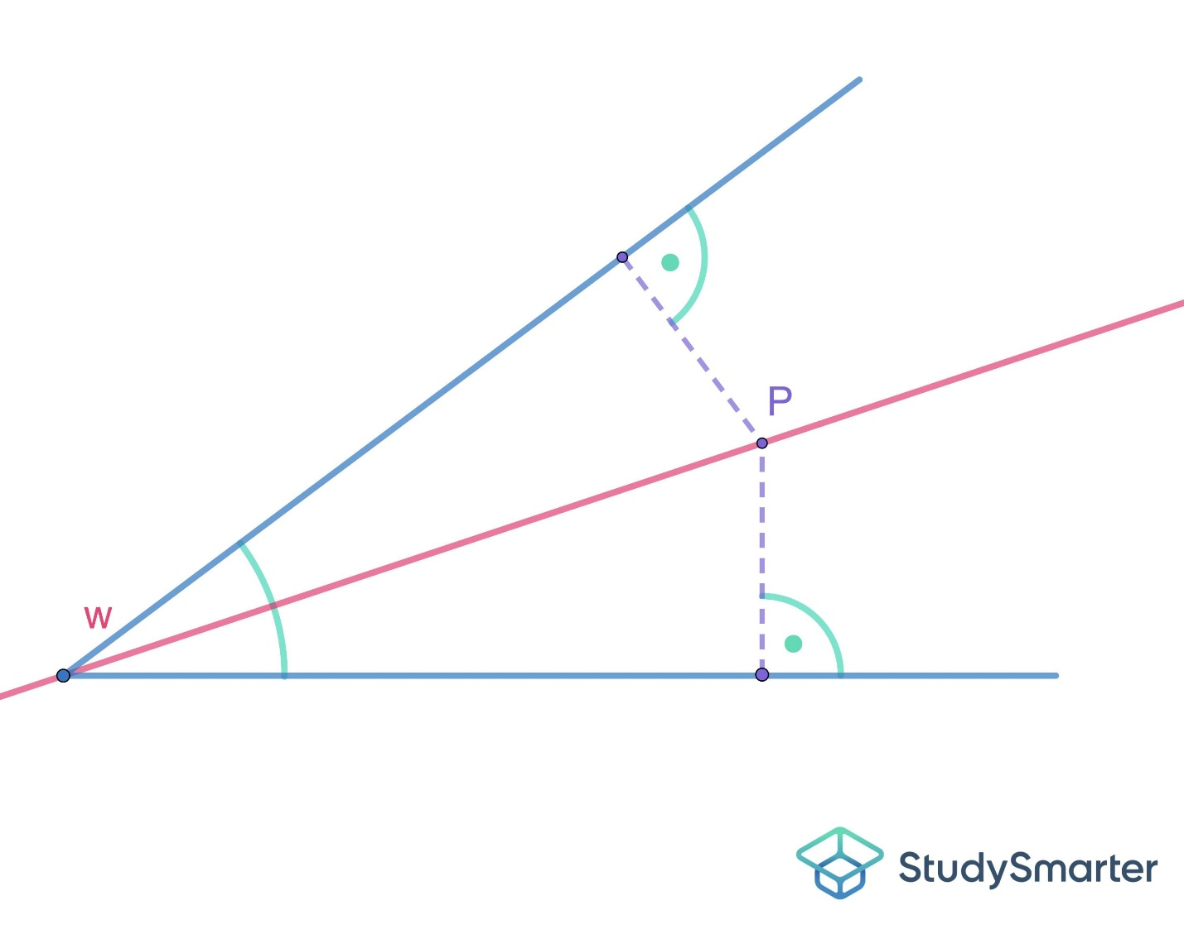
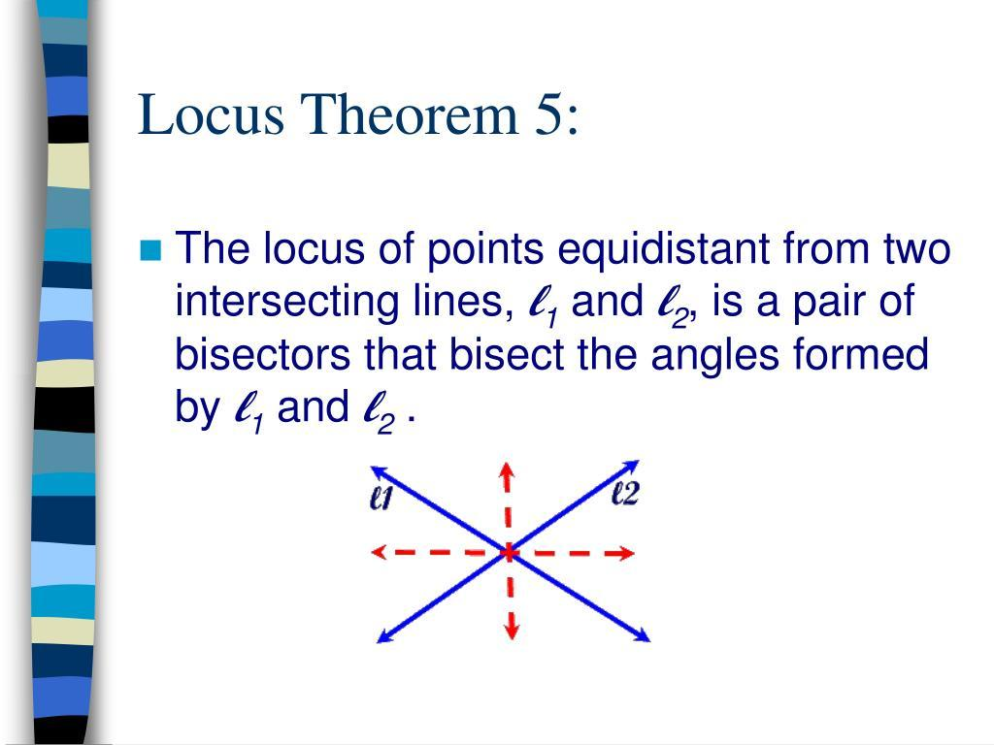
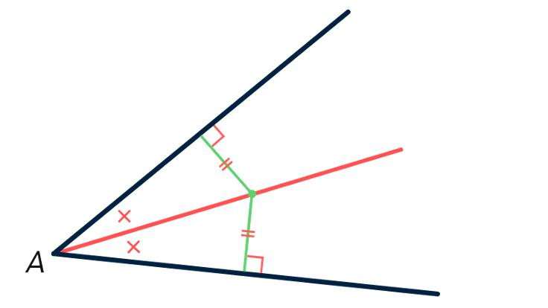

Simple Definition
# Source: AI Source: Provided by: [Data Path: Persons Table -> ID Column: 1, Name_En Column: Motasem Essam] -> From: [ChatGPT] on [7/25/2026]
The angle bisector is the locus of points that are equally distant from the two sides of an angle.
For an angle formed by rays $OA$and $OB$, the internal angle bisector satisfies
$$\boxed{d\left(P , OA\right)=d\left(P , OB\right)}.$$
If all points in the plane are considered, the complete equidistance locus includes both the internal and external angle bisectors.

Fundamental Concept
# Source: AI Source: Provided by: [Data Path: Persons Table -> ID Column: 1, Name_En Column: Motasem Essam] -> From: [ChatGPT] on [7/25/2026]
Consider two intersecting lines $l_{1}$and $l_{2}$.
A point $P$has a perpendicular distance to each line:
$$d\left(P , l_{1}\right)$$
and
$$d\left(P , l_{2}\right).$$
We are looking for points satisfying
$$d\left(P , l_{1}\right)=d\left(P , l_{2}\right).$$
These points lie on the angle bisectors of the angles formed by the two lines.
Therefore:
$$\boxed{\text{Equidistant from Two Intersecting Lines}→\text{Angle Bisectors}}$$

Angle Bisector as a Locus
# Source: AI Source: Provided by: [Data Path: Persons Table -> ID Column: 1, Name_En Column: Motasem Essam] -> From: [ChatGPT] on [7/25/2026]
Suppose $∠AOB$is an angle.
A point $P$lies on its internal angle bisector if
$$\boxed{d\left(P , OA\right)=d\left(P , OB\right)}.$$
In other words, the perpendicular distance from $P$to one side of the angle equals the perpendicular distance from $P$to the other side.
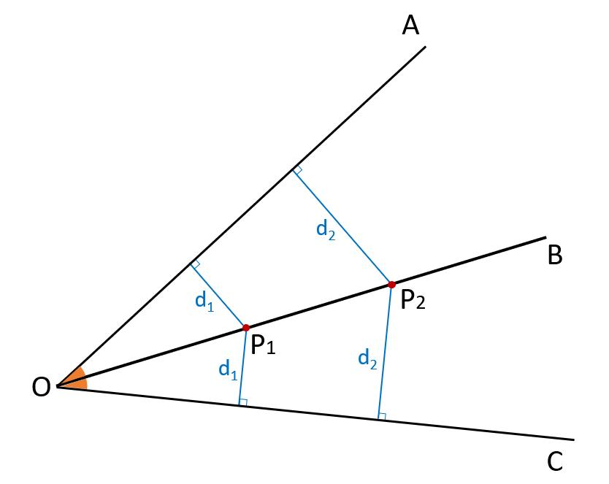
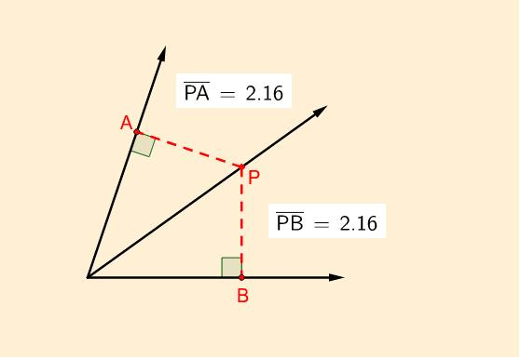
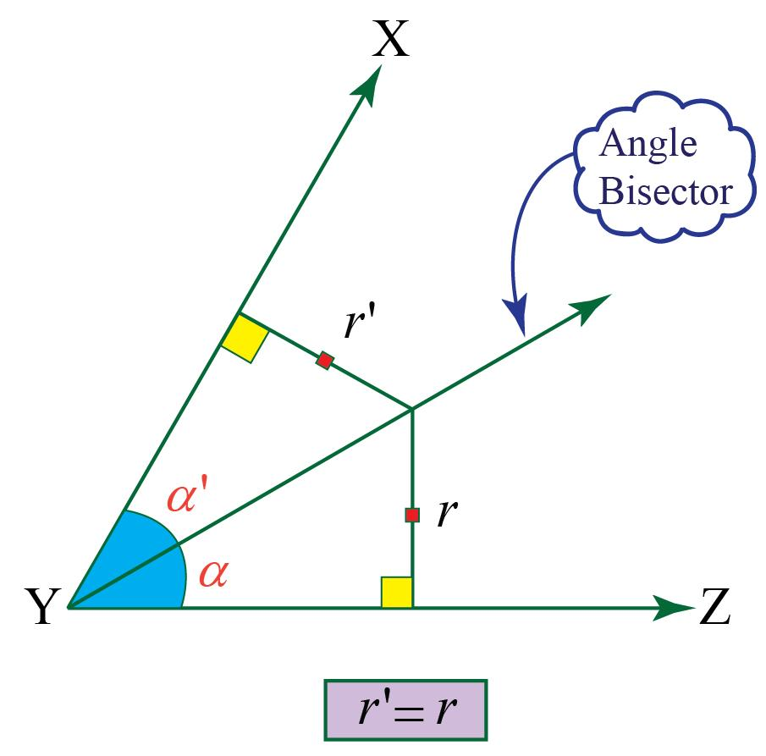
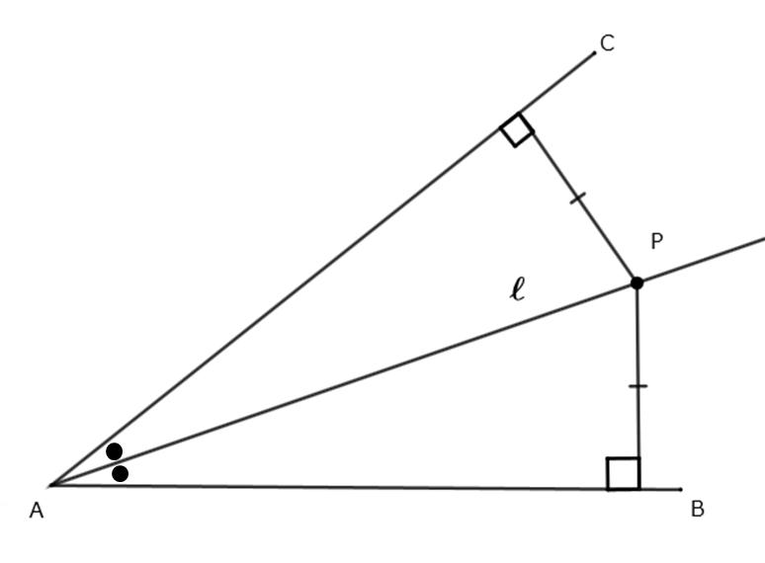
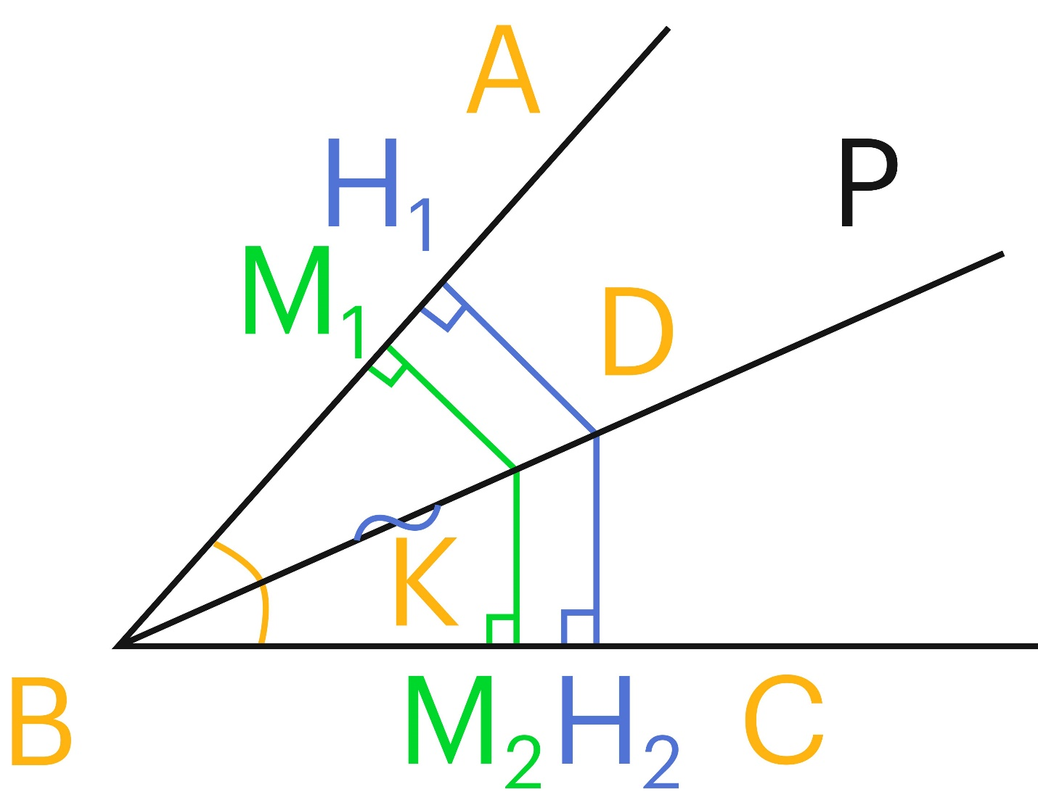

Why Does the Angle Bisector Form the Locus?
# Source: AI Source: Provided by: [Data Path: Persons Table -> ID Column: 1, Name_En Column: Motasem Essam] -> From: [ChatGPT] on [7/25/2026]
Let $P$lie on the internal angle bisector of $∠AOB$.
Draw perpendiculars from $P$to the two sides:
$$PM⊥OA$$
and
$$PN⊥OB.$$
Because $OP$bisects the angle,
$$∠MOP=∠PON.$$
Also,
$$OP=OP$$
and
$$∠OMP=∠ONP={90}^{∘}.$$
Therefore, the right triangles
$$△OMP$$
and
$$△ONP$$
are congruent.
Hence:
$$\boxed{PM=PN}.$$
But $PM$and $PN$are the perpendicular distances from $P$to the two sides.
Therefore:
$$\boxed{d\left(P , OA\right)=d\left(P , OB\right)}.$$

Converse: Equal Distances Produce the Angle Bisector
# Source: AI Source: Provided by: [Data Path: Persons Table -> ID Column: 1, Name_En Column: Motasem Essam] -> From: [ChatGPT] on [7/25/2026]
The converse is essential for the locus definition.
Suppose a point $P$has equal perpendicular distances to the two sides:
$$\boxed{d\left(P , OA\right)=d\left(P , OB\right)}.$$
Let
$$PM⊥OA$$
and
$$PN⊥OB.$$
Then:
$$PM=PN.$$
The right triangles $OMP$and $ONP$have:
$$PM=PN, \\ OP=OP,$$
and both contain a right angle.
Therefore, they are congruent.
Hence:
$$∠MOP=∠PON.$$
Therefore, $OP$bisects the angle.
So:
$$\boxed{d\left(P , OA\right)=d\left(P , OB\right)⇒P\text{ lies on an angle bisector}}$$
Together:
$$\boxed{d\left(P , OA\right)=d\left(P , OB\right) ⟺ P\text{ lies on an angle bisector}}$$

Internal Angle-Bisector Locus
# Source: AI Source: Provided by: [Data Path: Persons Table -> ID Column: 1, Name_En Column: Motasem Essam] -> From: [ChatGPT] on [7/25/2026]
For a particular angle $∠AOB$, if we restrict $P$to points inside that angle, the locus is the internal angle bisector.
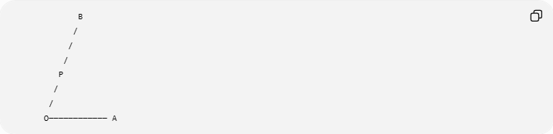
B
/
/
/
P
/
/
O──────────── A
For every point $P$on the internal bisector:
$$\boxed{d\left(P , OA\right)=d\left(P , OB\right)}.$$
Thus:
$$\boxed{\text{Points inside an angle and equidistant from its sides}→\text{Internal Angle Bisector}}$$

External Angle-Bisector Locus
# Source: AI Source: Provided by: [Data Path: Persons Table -> ID Column: 1, Name_En Column: Motasem Essam] -> From: [ChatGPT] on [7/25/2026]
Two intersecting lines create four angles.
Consequently, there are two perpendicular angle-bisector lines:
- the internal angle bisector,
- the external angle bisector.
If the complete plane is considered, both belong to the equidistance locus.
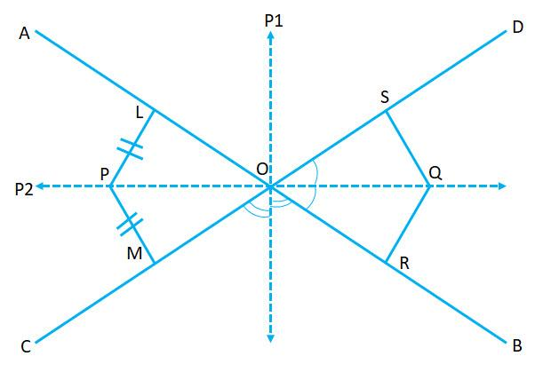
Therefore:
$$\boxed{\text{Complete locus}=\text{Internal angle bisector}∪\text{External angle bisector}}$$

Why Are There Two Angle Bisectors?
# Source: AI Source: Provided by: [Data Path: Persons Table -> ID Column: 1, Name_En Column: Motasem Essam] -> From: [ChatGPT] on [7/25/2026]
Suppose two lines intersect at $O$.
They form four angles:
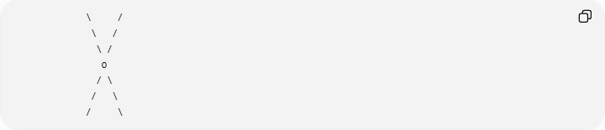
\ /
\ /
\ /
O
/ \
/ \
/ \
The points that have equal unsigned perpendicular distances from the two lines occur on two perpendicular lines.
Therefore:
$$\boxed{\text{Two intersecting lines}→\text{Two angle-bisector lines}}$$
The two angle bisectors are perpendicular:
$$\boxed{l_{\text{internal}}⊥l_{\text{external}}}.$$

Angle Bisector and Equal Distance
# Source: AI Source: Provided by: [Data Path: Persons Table -> ID Column: 1, Name_En Column: Motasem Essam] -> From: [ChatGPT] on [7/25/2026]
This is the central locus relationship:
$$\boxed{P\text{ lies on an angle bisector }⟺ d\left(P , l_{1}\right)=d\left(P , l_{2}\right)}$$
where $l_{1}$and $l_{2}$are the two intersecting lines.
This is analogous to the perpendicular-bisector locus:
$$PA=PB ⟺ P\text{ lies on perpendicular bisector}.$$
So:
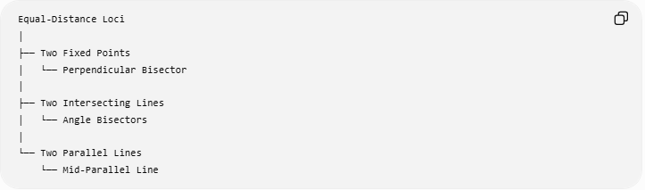
Equal-Distance Loci
│
├── Two Fixed Points
│ └── Perpendicular Bisector
│
├── Two Intersecting Lines
│ └── Angle Bisectors
│
└── Two Parallel Lines
└── Mid-Parallel Line

Example
# Source: AI Source: Provided by: [Data Path: Persons Table -> ID Column: 1, Name_En Column: Motasem Essam] -> From: [ChatGPT] on [7/25/2026]
Consider the angle formed by
$$y=0$$
and
$$x=0.$$
These are the $x$-axis and $y$-axis.
For a point
$$P=\left(x , y\right),$$
its distance from the $x$-axis is
$$∣y∣$$
and its distance from the $y$-axis is
$$∣x∣.$$
For equal distances:
$$∣x∣=∣y∣.$$
Therefore:
$$\boxed{x=y}$$
or
$$\boxed{x=-y}.$$
These are the two angle bisectors of the coordinate axes.
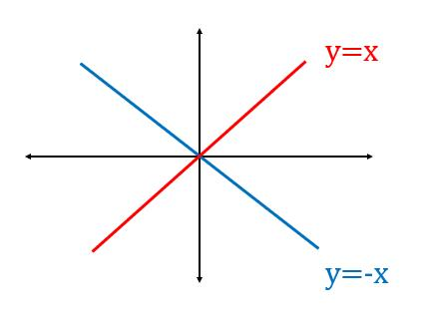
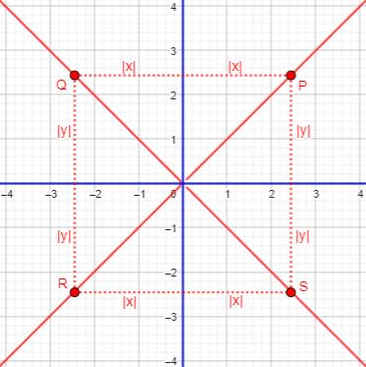
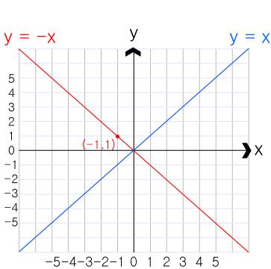

Coordinate Equation for Two General Lines
# Source: AI Source: Provided by: [Data Path: Persons Table -> ID Column: 1, Name_En Column: Motasem Essam] -> From: [ChatGPT] on [7/25/2026]
Suppose the two lines are
$$l_{1}:a_{1}x+b_{1}y+c_{1}=0$$
and
$$l_{2}:a_{2}x+b_{2}y+c_{2}=0.$$
The perpendicular distance from $P=\left(x , y\right)$to $l_{1}$is
$$d\left(P , l_{1}\right)=\frac{∣a_{1}x+b_{1}y+c_{1}∣}{\sqrt{a_{1}^{2}+b_{1}^{2}}}.$$
Similarly,
$$d\left(P , l_{2}\right)=\frac{∣a_{2}x+b_{2}y+c_{2}∣}{\sqrt{a_{2}^{2}+b_{2}^{2}}}.$$
For equal distances:
$$\boxed{\frac{∣a_{1}x+b_{1}y+c_{1}∣}{\sqrt{a_{1}^{2}+b_{1}^{2}}}=\frac{∣a_{2}x+b_{2}y+c_{2}∣}{\sqrt{a_{2}^{2}+b_{2}^{2}}}}$$
Removing the absolute-value ambiguity gives the two angle bisectors:
$$\boxed{\frac{a_{1}x+b_{1}y+c_{1}}{\sqrt{a_{1}^{2}+b_{1}^{2}}}=±\frac{a_{2}x+b_{2}y+c_{2}}{\sqrt{a_{2}^{2}+b_{2}^{2}}}}$$
The $+$and $-$cases correspond to the two angle-bisector lines.

Example with General Lines
# Source: AI Source: Provided by: [Data Path: Persons Table -> ID Column: 1, Name_En Column: Motasem Essam] -> From: [ChatGPT] on [7/25/2026]
Consider
$$l_{1}:y=0$$
and
$$l_{2}:y=x.$$
The distance from $P=\left(x , y\right)$to $l_{1}$is
$$∣y∣.$$
Write $l_{2}$as
$$x-y=0.$$
Its distance is
$$\frac{∣x-y∣}{\sqrt{2}}.$$
Set them equal:
$$∣y∣=\frac{∣x-y∣}{\sqrt{2}}.$$
Squaring:
$$2y^{2}={\left(x-y\right)}^{2}.$$
Therefore:
$$2y^{2}=x^{2}-2xy+y^{2} \\ y^{2}=x^{2}-2xy \\ x^{2}-2xy-y^{2}=0.$$
Factoring into two lines gives the two angle bisectors.

Angle Bisector in a Triangle
# Source: AI Source: Provided by: [Data Path: Persons Table -> ID Column: 1, Name_En Column: Motasem Essam] -> From: [ChatGPT] on [7/25/2026]
For a triangle
$$△ABC,$$
the internal angle bisector of $∠A$is the locus of points equidistant from the two sides
$$AB$$
and
$$AC$$
within the angle.
Thus, if $P$lies on the angle bisector of $∠A$:
$$\boxed{d\left(P , AB\right)=d\left(P , AC\right)}.$$
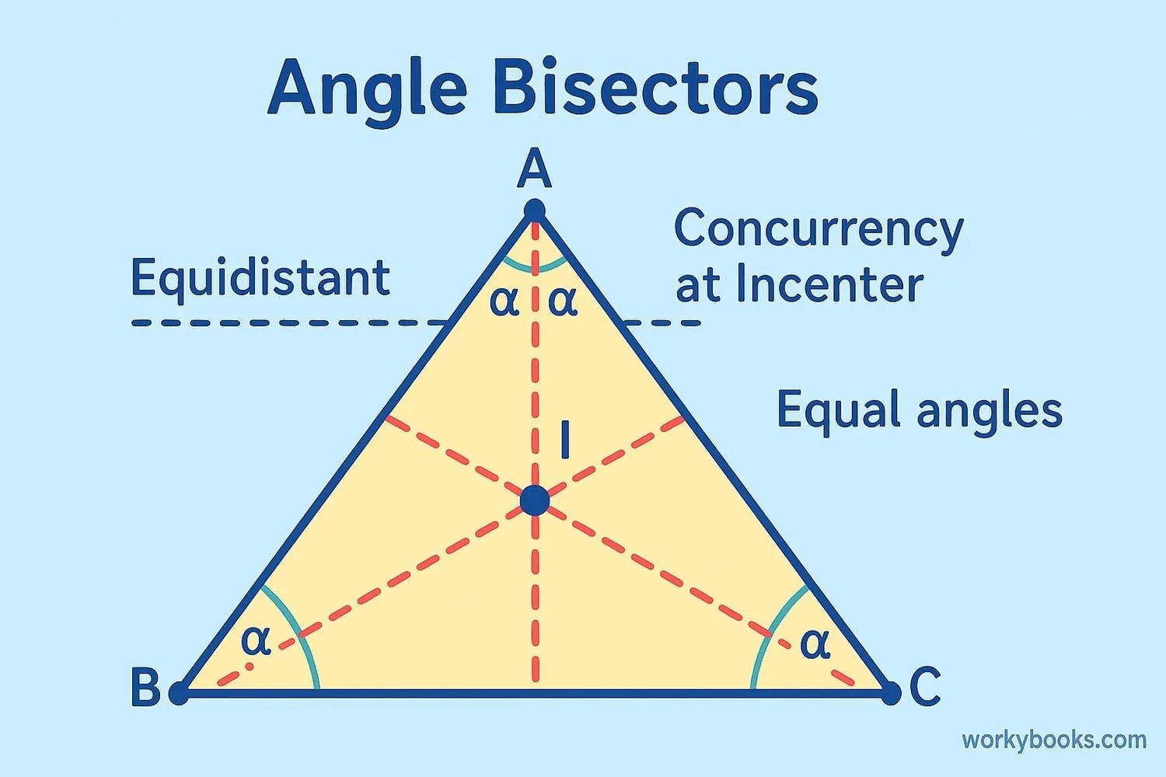
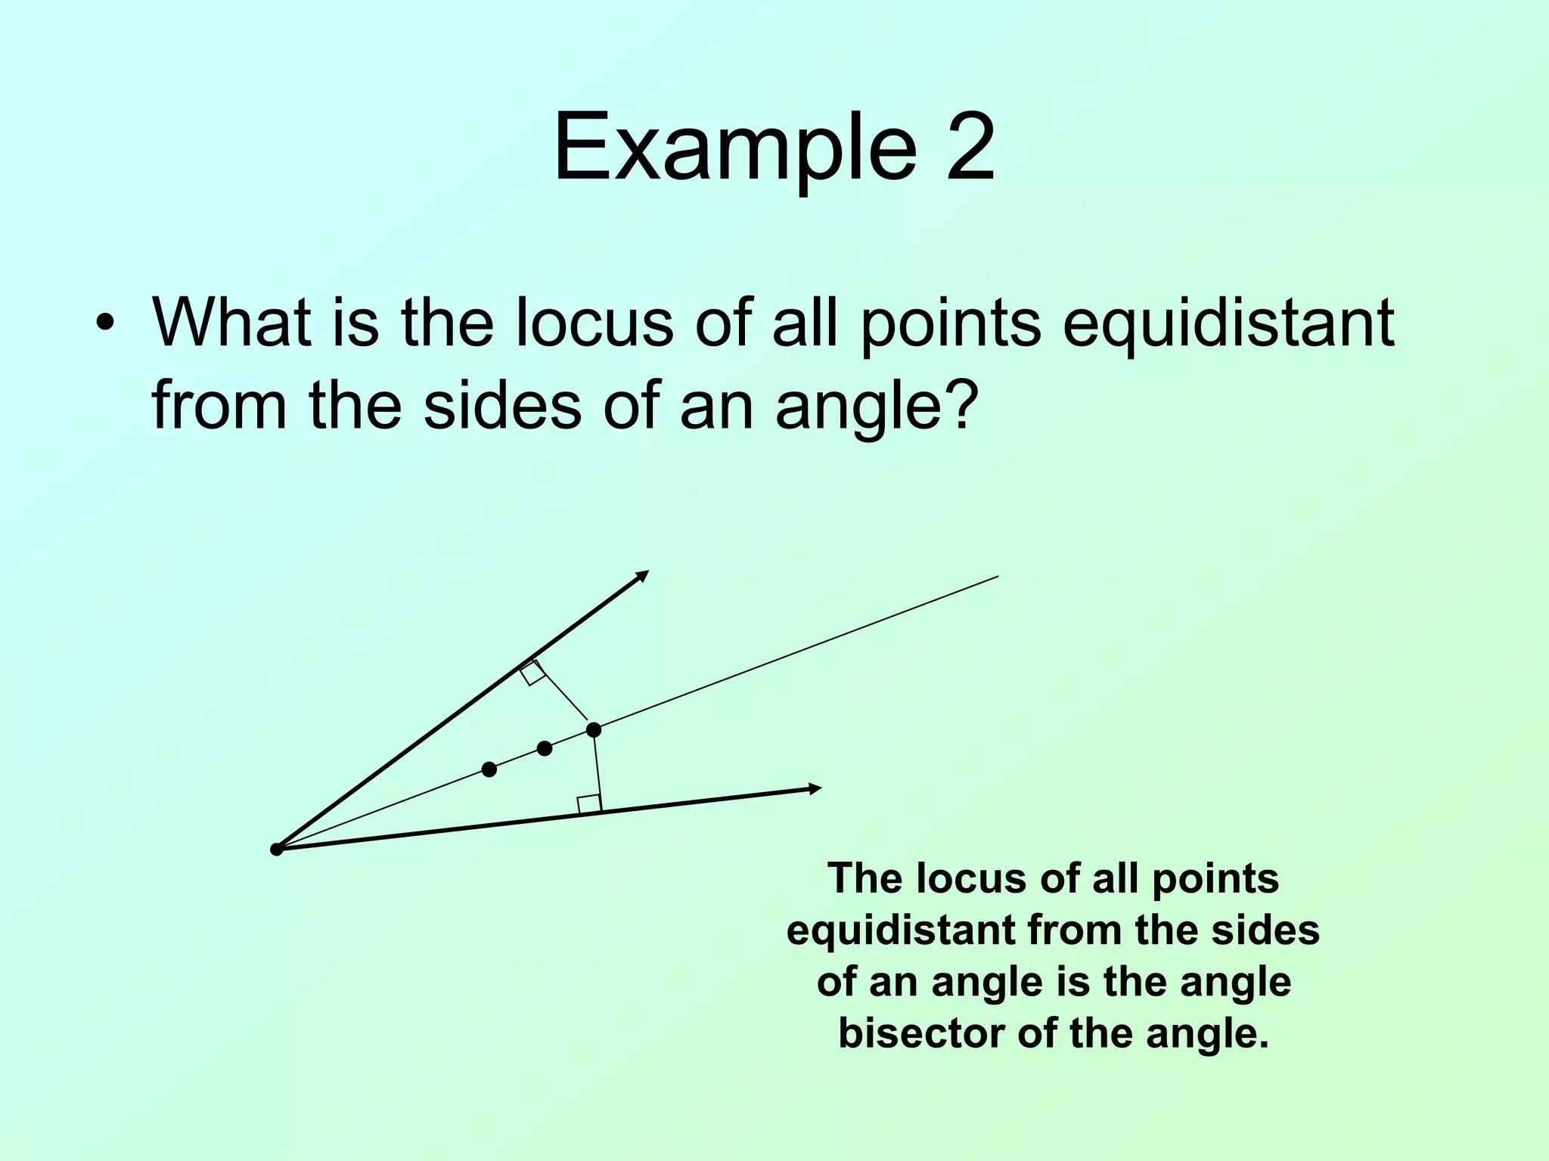
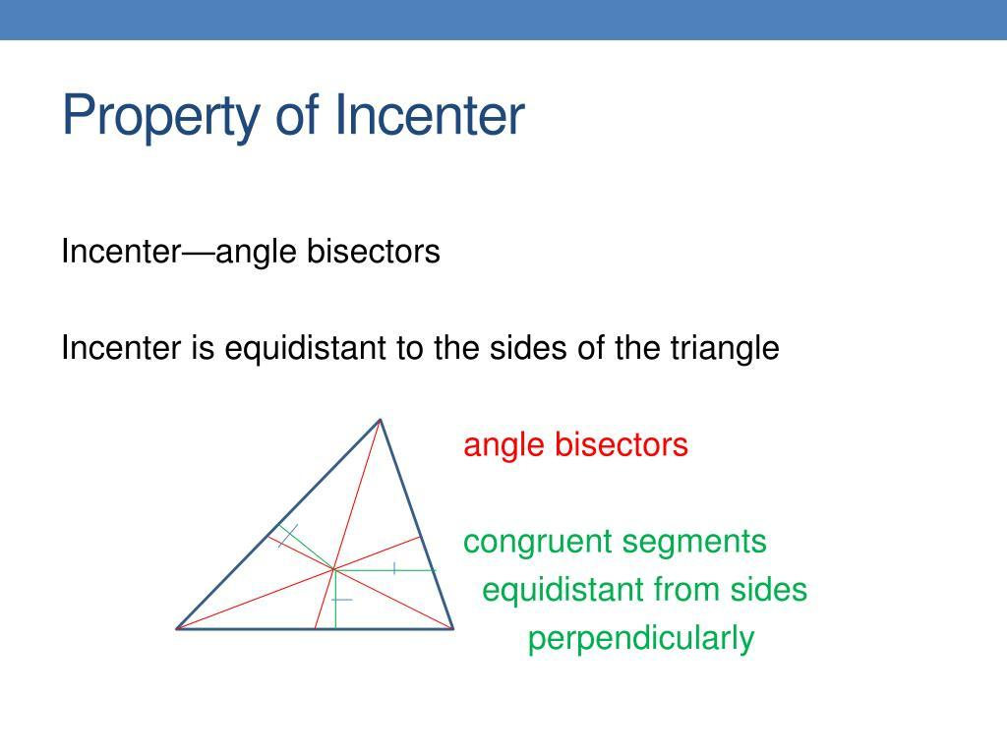
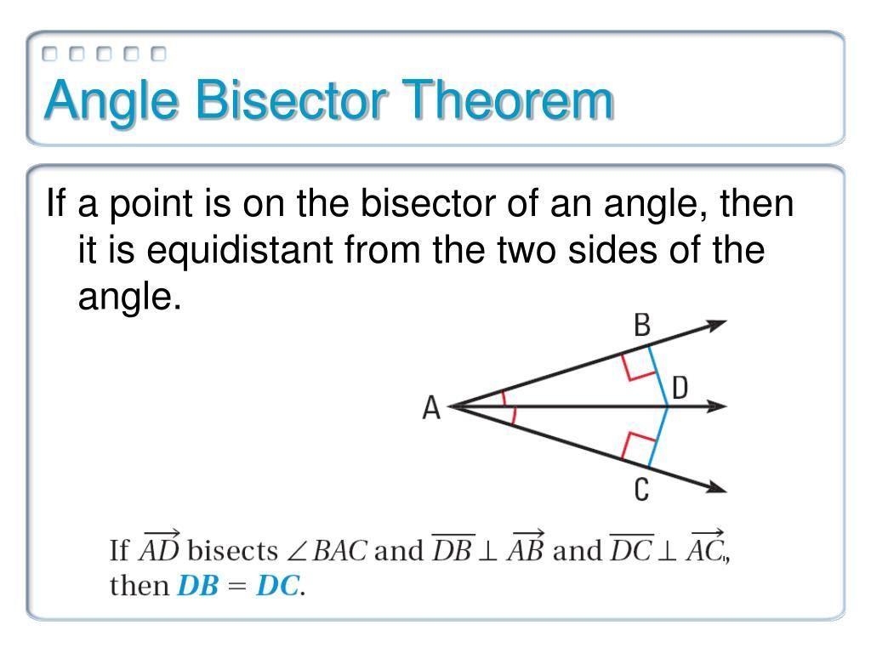

The Incenter as a Locus Intersection
# Source: AI Source: Provided by: [Data Path: Persons Table -> ID Column: 1, Name_En Column: Motasem Essam] -> From: [ChatGPT] on [7/25/2026]
The incenter of a triangle is particularly important from the locus viewpoint.
For $△ABC$, the incenter $I$is equidistant from all three sides:
$$\boxed{d\left(I , AB\right)=d\left(I , BC\right)=d\left(I , CA\right)}$$
It is the intersection of the three internal angle bisectors.
Therefore:
$$\boxed{\text{Angle-Bisector Loci}→\text{Incenter}}$$
and the common distance is the inradius $r$.
$$\boxed{d\left(I , AB\right)=d\left(I , BC\right)=d\left(I , CA\right)=r}$$

Angle Bisector and Incircle
# Source: AI Source: Provided by: [Data Path: Persons Table -> ID Column: 1, Name_En Column: Motasem Essam] -> From: [ChatGPT] on [7/25/2026]
Once the incenter $I$is known, draw a perpendicular from $I$to any side.
If
$$ID⊥AB,$$
then
$$ID=r.$$
Because the incenter has equal distances to all three sides:
$$ID=IE=IF=r.$$
The circle centered at $I$with radius $r$is the incircle.
Thus:
$$\boxed{\text{Angle-Bisector Loci}→\text{Incenter}→\text{Incircle}}$$
This parallels the circumcircle construction:
$$\boxed{\text{Perpendicular-Bisector Loci}→\text{Circumcenter}→\text{Circumcircle}}$$

Angle Bisector vs Perpendicular Bisector
# Source: AI Source: Provided by: [Data Path: Persons Table -> ID Column: 1, Name_En Column: Motasem Essam] -> From: [ChatGPT] on [7/25/2026]
These two loci are frequently confused.
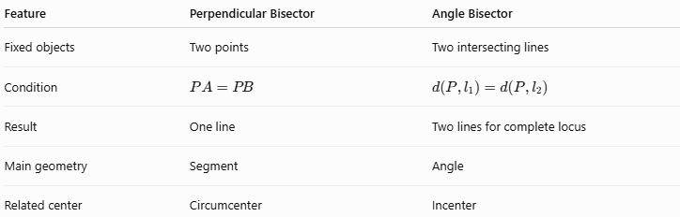
Feature | Perpendicular Bisector | Angle Bisector
Fixed objects | Two points | Two intersecting lines
Condition | $$PA=PB$$ | $$d\left(P , l_{1}\right)=d\left(P , l_{2}\right)$$
Result | One line | Two lines for complete locus
Main geometry | Segment | Angle
Related center | Circumcenter | Incenter
The key distinction is:
$$\boxed{\text{Equal distance from two points}→\text{Perpendicular bisector}}$$
while
$$\boxed{\text{Equal distance from two lines}→\text{Angle bisectors}}$$

Angle Bisector vs Fixed-Angle Locus
# Source: AI Source: Provided by: [Data Path: Persons Table -> ID Column: 1, Name_En Column: Motasem Essam] -> From: [ChatGPT] on [7/25/2026]
These are also different.
Angle-bisector locus
The location of $P$determines equal distances to the two sides:
$$\boxed{d\left(P , l_{1}\right)=d\left(P , l_{2}\right)}.$$
Result:
$$\boxed{\text{Angle bisector}}.$$
Fixed-angle locus
The angle formed at $P$is fixed:
$$\boxed{∠APB=θ}.$$
Result:
$$\boxed{\text{Circular arc(s)}}.$$
So:
$$\boxed{\text{Equal distances from sides}≠\text{Fixed angle at point}}$$

Construction of an Angle-Bisector Locus
# Source: AI Source: Provided by: [Data Path: Persons Table -> ID Column: 1, Name_En Column: Motasem Essam] -> From: [ChatGPT] on [7/25/2026]
For an angle $∠AOB$:
- Draw the angle.
- With center $O$, draw an arc intersecting both sides at $M$and $N$.
- With equal compass radius, draw arcs centered at $M$and $N$.
- Let their intersection be $P$.
- Draw $OP$.
Then $OP$is the internal angle bisector.
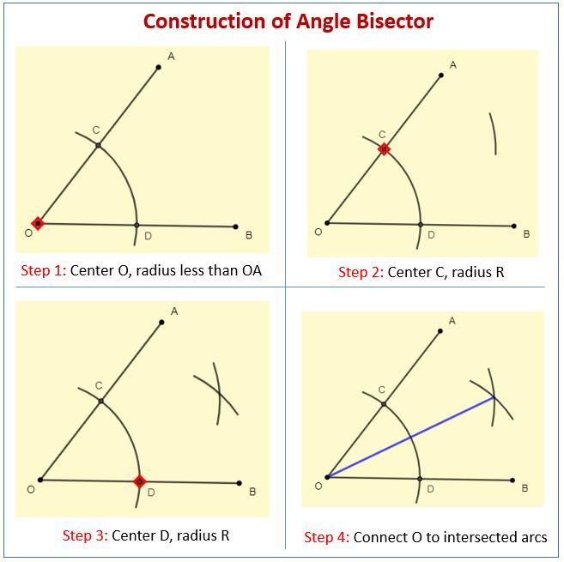
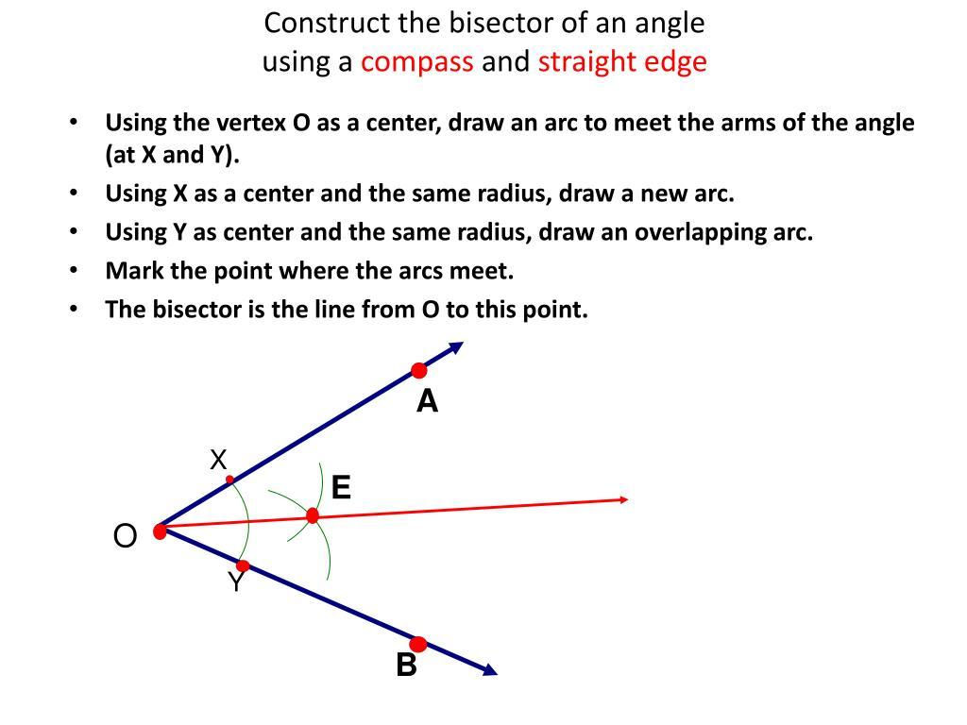
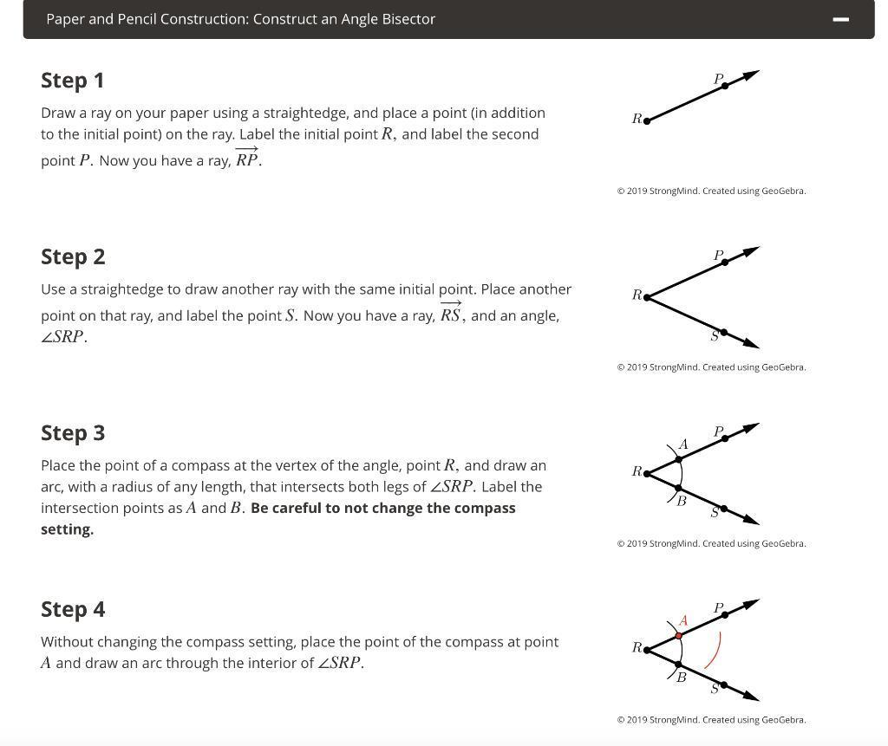
The construction works because the constructed point $P$is equidistant from the two sides.

Important Special Case: Parallel Lines
# Source: AI Source: Provided by: [Data Path: Persons Table -> ID Column: 1, Name_En Column: Motasem Essam] -> From: [ChatGPT] on [7/25/2026]
If the two lines do not intersect but are parallel, there are no angle bisectors in the ordinary intersecting-line sense.
Instead, the locus of points equidistant from the two parallel lines is a single line halfway between them.
For example:
$$y=2$$
and
$$y=8.$$
The equidistant locus is
$$\boxed{y=5}.$$
Therefore:
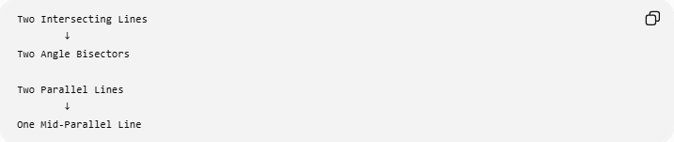
Two Intersecting Lines
↓
Two Angle Bisectors

Two Parallel Lines
↓
One Mid-Parallel Line

Important Special Case: Restricting to One Angle
# Source: AI Source: Provided by: [Data Path: Persons Table -> ID Column: 1, Name_En Column: Motasem Essam] -> From: [ChatGPT] on [7/25/2026]
If a problem says:
Find the locus of points inside $∠AOB$that are equidistant from $OA$and $OB$.
then only the internal angle bisector is included.
If the problem says:
Find all points in the plane equidistant from the two lines $OA$and $OB$.
then both angle-bisector lines are included.
This distinction is important when describing the complete locus.

Applications
# Source: AI Source: Provided by: [Data Path: Persons Table -> ID Column: 1, Name_En Column: Motasem Essam] -> From: [ChatGPT] on [7/25/2026]
1. Finding the incenter
The intersection of two internal angle bisectors gives the incenter.
2. Constructing an incircle
After finding the incenter, use its perpendicular distance to a side as the radius.
3. Finding points equally distant from two roads or lines
If two roads are modeled by intersecting lines, their angle bisectors give locations equally distant from both.
4. Geometric construction
Angle bisectors can be constructed using compass and straightedge.
5. Distance optimization
Angle-bisector loci can separate regions according to equal distance from two intersecting boundaries.

Classification
# Source: AI Source: Provided by: [Data Path: Persons Table -> ID Column: 1, Name_En Column: Motasem Essam] -> From: [ChatGPT] on [7/25/2026]
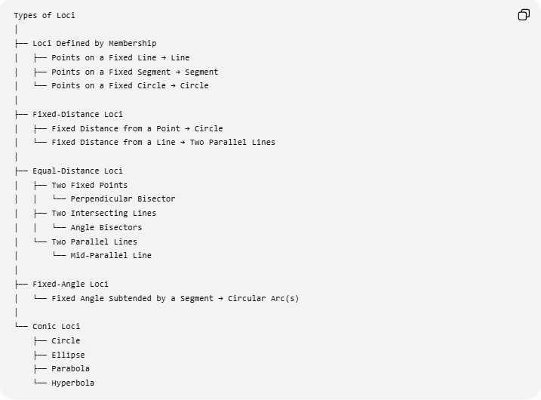
Types of Loci
│
├── Loci Defined by Membership
│ ├── Points on a Fixed Line → Line
│ ├── Points on a Fixed Segment → Segment
│ └── Points on a Fixed Circle → Circle
│
├── Fixed-Distance Loci
│ ├── Fixed Distance from a Point → Circle
│ └── Fixed Distance from a Line → Two Parallel Lines
│
├── Equal-Distance Loci
│ ├── Two Fixed Points
│ │ └── Perpendicular Bisector
│ ├── Two Intersecting Lines
│ │ └── Angle Bisectors
│ └── Two Parallel Lines
│ └── Mid-Parallel Line
│
├── Fixed-Angle Loci
│ └── Fixed Angle Subtended by a Segment → Circular Arc(s)
│
└── Conic Loci
├── Circle
├── Ellipse
├── Parabola
└── Hyperbola
Key Formulas
Equal-distance condition
$$\boxed{d\left(P , l_{1}\right)=d\left(P , l_{2}\right)}$$
General line-distance formula
For
$$ax+by+c=0,$$
the distance from $P=\left(x_{0} , y_{0}\right)$is
$$\boxed{d=\frac{∣ax_{0}+by_{0}+c∣}{\sqrt{a^{2}+b^{2}}}}$$
Angle-bisector equation
For
$$a_{1}x+b_{1}y+c_{1}=0$$
and
$$a_{2}x+b_{2}y+c_{2}=0,$$
the two angle bisectors satisfy
$$\boxed{\frac{a_{1}x+b_{1}y+c_{1}}{\sqrt{a_{1}^{2}+b_{1}^{2}}}=±\frac{a_{2}x+b_{2}y+c_{2}}{\sqrt{a_{2}^{2}+b_{2}^{2}}}}$$
Incenter condition
$$\boxed{d\left(I , AB\right)=d\left(I , BC\right)=d\left(I , CA\right)=r}$$

Classification Summary
# Source: AI Source: Provided by: [Data Path: Persons Table -> ID Column: 1, Name_En Column: Motasem Essam] -> From: [ChatGPT] on [7/25/2026]
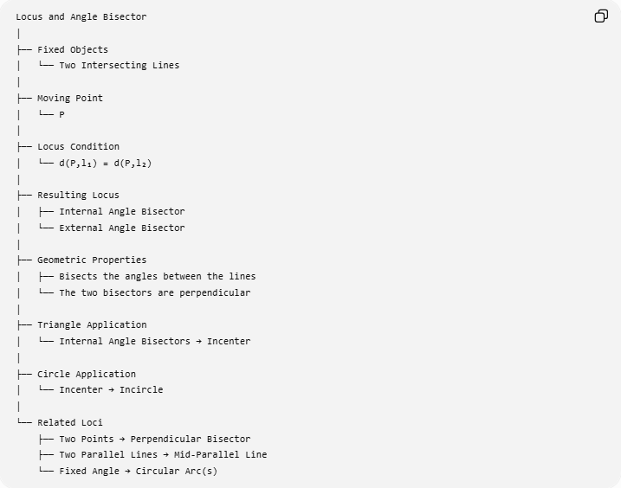
Locus and Angle Bisector
│
├── Fixed Objects
│ └── Two Intersecting Lines
│
├── Moving Point
│ └── P
│
├── Locus Condition
│ └── d(P,l₁) = d(P,l₂)
│
├── Resulting Locus
│ ├── Internal Angle Bisector
│ └── External Angle Bisector
│
├── Geometric Properties
│ ├── Bisects the angles between the lines
│ └── The two bisectors are perpendicular
│
├── Triangle Application
│ └── Internal Angle Bisectors → Incenter
│
├── Circle Application
│ └── Incenter → Incircle
│
└── Related Loci
├── Two Points → Perpendicular Bisector
├── Two Parallel Lines → Mid-Parallel Line
└── Fixed Angle → Circular Arc(s)

Key Points
# Source: AI Source: Provided by: [Data Path: Persons Table -> ID Column: 1, Name_En Column: Motasem Essam] -> From: [ChatGPT] on [7/25/2026]
- The angle bisector is an equal-distance locus.
- For two intersecting lines:
$$\boxed{d\left(P , l_{1}\right)=d\left(P , l_{2}\right)}$$
defines the complete locus.
- The complete locus consists of two perpendicular angle-bisector lines.
- If $P$is restricted to one angle, only that angle's bisector is relevant.
- In a triangle, the internal angle bisectors meet at the incenter.
- The incenter is equidistant from all three sides:
$$d\left(I , AB\right)=d\left(I , BC\right)=d\left(I , CA\right).$$
- The common distance is the inradius.
- For parallel lines, the equal-distance locus is a single middle parallel line rather than angle bisectors.
- The angle-bisector locus is different from the fixed-angle locus.

Conclusion
# Source: AI Source: Provided by: [Data Path: Persons Table -> ID Column: 1, Name_En Column: Motasem Essam] -> From: [ChatGPT] on [7/25/2026]
The Angle Bisector is a fundamental equal-distance locus. For two intersecting lines $l_{1}$and $l_{2}$, the points satisfying
$$\boxed{d\left(P , l_{1}\right)=d\left(P , l_{2}\right)}$$
form the two angle bisectors of the angles created by the lines.
The central relationship is:
$$\boxed{\text{Equidistance from Two Intersecting Lines }⟺\text{ Angle-Bisector Locus}}$$
For a triangle, this leads directly to the incenter:
$$\boxed{\text{Angle-Bisector Loci}→\text{Incenter}→\text{Incircle}}$$
This makes the angle-bisector locus one of the fundamental connections between loci, distance geometry, triangle centers, geometric constructions, and circle geometry.

